North African Shakshuka – baked egg dish
https://www.feastingathome.com/shakshuka-north-african-skillet-eggs/

Ingredients:
3 tbsp Olive oil
1 red onion, diced
1 large red bell pepper, thinly sliced or diced
1 large yellow bell pepper, sliced or diced
4 garlic cloves, rough chopped
3/4 tsp salt, more to taste
cracked pepper to taste
1 tsp cumin
1 tsp sugar
1 tsp smoked paprika
1/2 tsp aleppo chili flakes (optional)
3 medium tomatoes diced small with juices ( or one 14-ounce can diced tomatoes with juices)
1/3 cup water or white wine
2 tablespoons fresh basil ribbons, chopped cilantro or Italian parsley (optional)
4 –6 eggs

Instructions:
Preheat oven to 375F
In a skillet, heat olive oil over medium heat. Add the onion and cook until tender, about 5 minutes. Add the sliced peppers and garlic, and turn heat down to med-low and cook for 5-7 more minutes, until peppers are tender.
Add all spices, sugar and salt.

Cook for 2 more minutes. Add fresh tomatoes and water (or wine).
Simmer on low for 10-15 minutes, uncovered, adding more water if it gets too dry or thick. You want a saucy, stew-like consistency. After tomatoes cook down, taste, it should be full-flavored, so adjust salt, spices, and sugar if necessary.
With the back of a spoon, make a well for each egg in the stew. Crack the eggs into each well, sprinkling each egg with a little salt and cracked pepper and Aleppo chili flakes (optional).
Place in the 375F oven.
Bake until egg whites are become opaque and are cooked ( about 8-10 minutes) and yolks are still soft ( or to your desired doneness.)
Remove from oven and top with fresh basil (or cilantro or Italian Parsley) and goat cheese (optional)
Serve with bread or potato hash browns

*for potato hash browns:
Heat 2-3 tbsp of olive oil in skillet while boiling potatoes for a few minutes
Place diced potatoes in skillet
Stirring potatoes, cook on skillet for 5 minutes
Add a few dashes of salt
Remove once crispy

Latin American Pico de Gallo – fresh salsa
https://www.simplyrecipes.com/recipes/fresh_tomato_salsa/
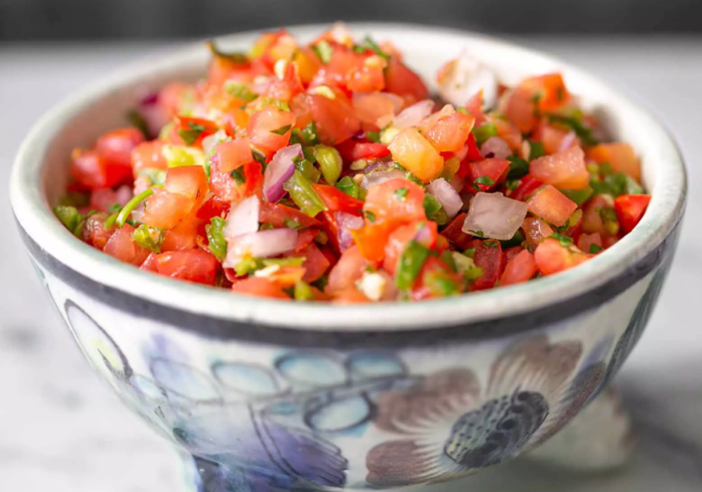

Ingredients:
2 to 3 medium fresh tomatoes
1/2 medium red onion
1 bell pepper
1 jalapeño pepper, stems, ribs, and seeds removed (less or more to taste)
Juice of 1 lime
1/2 cup chopped cilantro
Salt and pepper to taste
1 pinch dried oregano (crumble in your fingers before adding), or more to taste
1 pinch ground cumin, or more to taste

Instructions:
Chop all of the vegetables
Place all ingredients in a blender/food processor or dice by hand, place in a bowl & mix well

Hungarian Parsley Potatoes
https://eatingeuropean.com/parsley-potatoes/

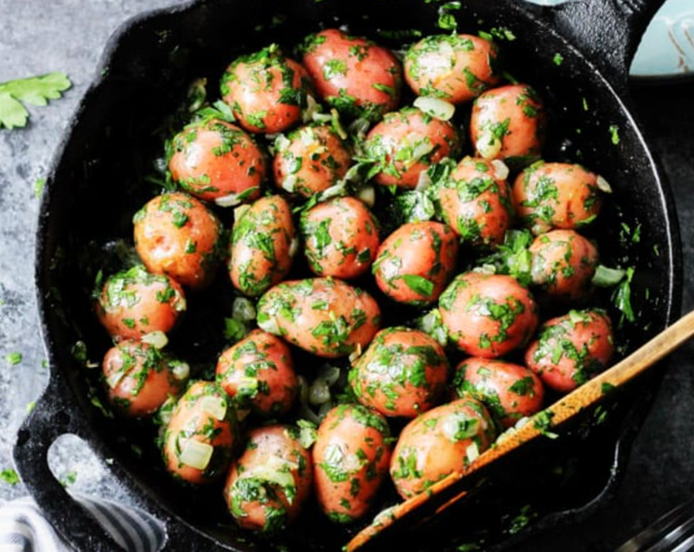
Ingredients:
Small red or white potatoes
1 sweet Onion
A bunch of Parsley
2 tbsp olive oil
Salt & Pepper, to season the dish
3-4 chives

Instructions:
Boil potatoes for ~20min
Chop onions & heat olive oil in skillet. Add onions to skillet & sauté
Cut chives
Drain potatoes
Add potatoes, chives, parsley, salt & pepper to skillet (keep as whole or cut potatoes into pieces)
Serve

Italian Pesto Sauce
https://www.simplyrecipes.com/recipes/fresh_basil_pesto/

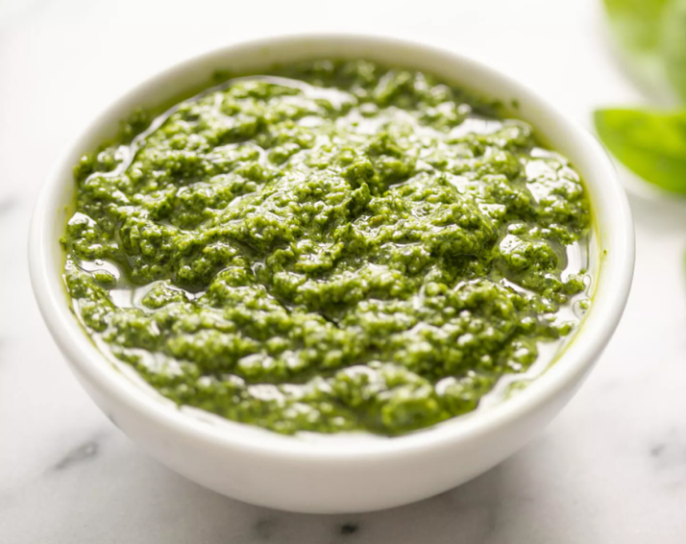
Ingredients:
2 cups fresh basil leaves, packed (can sub half the basil leaves with baby spinach)
1/2 cup freshly grated Romano or Parmesan cheese
1/2 cup olive oil
1/3 cup pine nuts (can sub chopped walnuts)
3 cloves garlic, minced (about 1 tablespoon)
1/4 teaspoon salt, or more to taste
1/8 teaspoon black pepper, or more to taste

Instructions:
In a food processor or blender, blend basil and pine nuts
Add garlic & cheese, blend
Slowly add the olive oil as the food processor is going
Add salt & pepper to taste

Eggplant with Spicy Garlic Sauce
https://steamykitchen.com/30476-chinese-eggplant-recipe-spicy-garlic-sauce.html

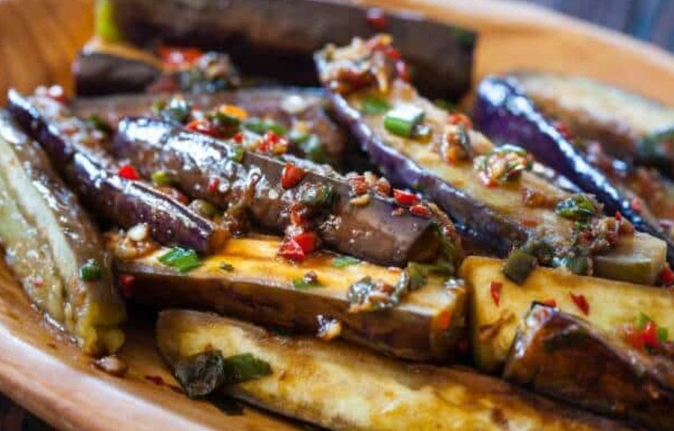

Ingredients:
2 tbsps cooking oil (divided)
3 small eggplant (cut into long strips)
2 cloves garlic finely minced
1 red chile pepper finely minced
1/2 inch fresh ginger peeled and finely minced
1 green onion, chopped
1 tbsp soy sauce
1 tbsp black vinegar (Chinese black vinegar)
1/2 tsp sugar

Instructions:
In a wok or saucepan over high heat, add 1 tablespoon of the cooking oil and swirl to coat wok. When wok is hot, add eggplant in a single layer. Cook 2 minutes and flip each piece to cook evenly. Cook another 2-3 minutes, flipping occasionally.
The eggplant should have changed in color, the skin wrinkled and the flesh soft.
Push eggplant aside in wok and add 1 tablespoon cooking oil. Add garlic, red chile peppers, ginger and green onion. Stir until they become fragrant. Combine them with eggplant and fry for one minutem, stirring often. Add soy sauce, black vinegar and sugar and stir to combine all

